

Index
Flow 3
Login 3
New Employee 4
New Lunch 4
New Menu 6
New Order 7

Flow

Registered Employees and Lunch

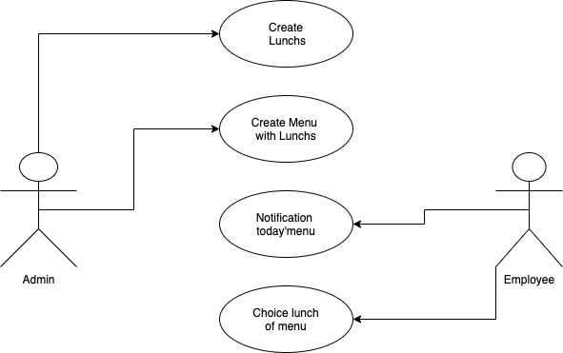

Login

http://192.168.33.10:8000/login/

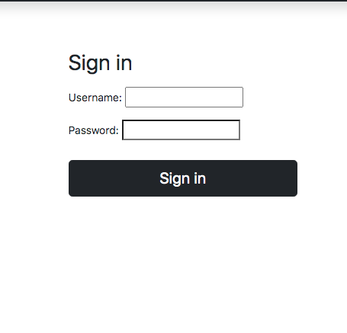

After login

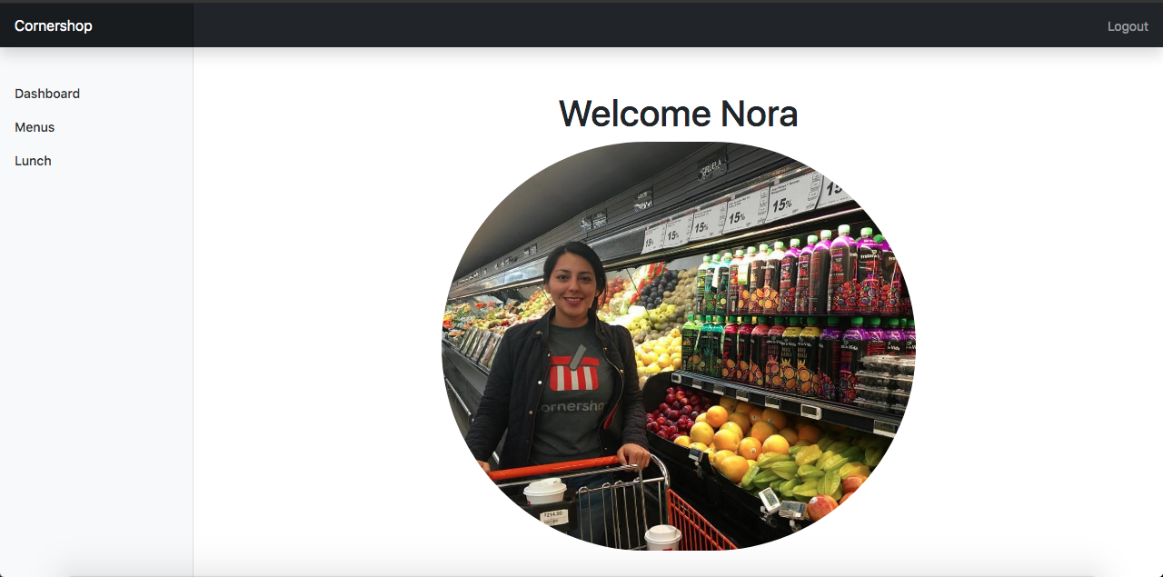

New Employee

The employees are created for a user admin, you only can see them.

New Lunch
Clik option Luch

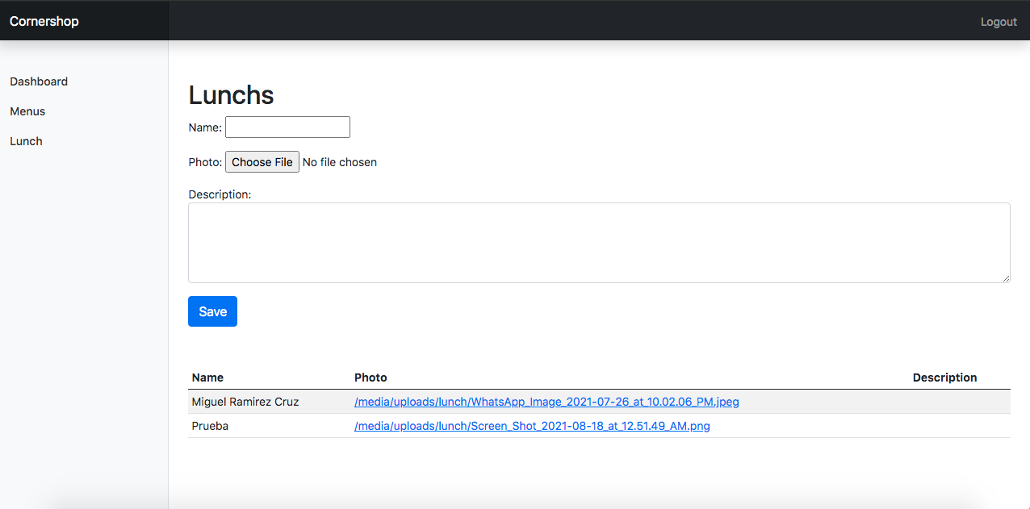
Now created Lunch
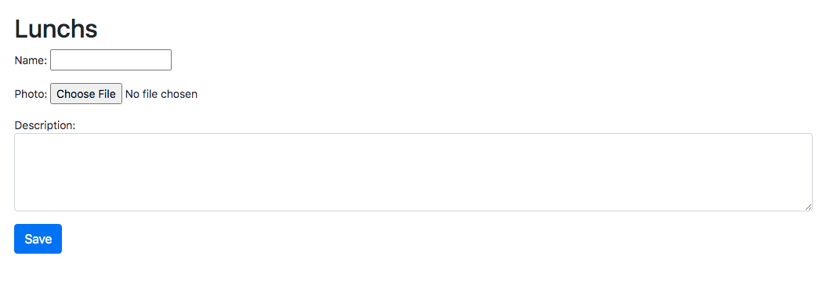

Lunch saved
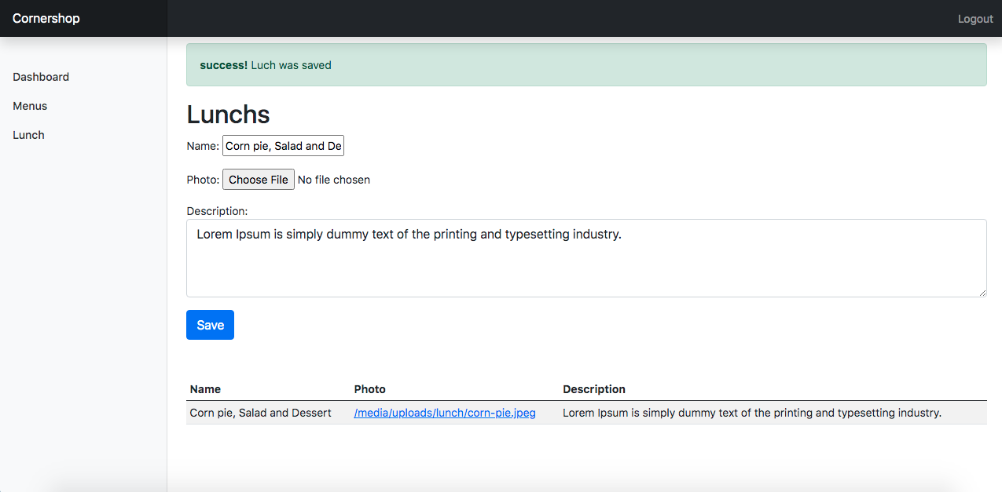

New Menu
Click option menu and save menu

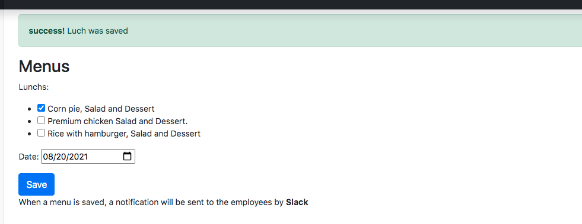

There will only be one menu for each date

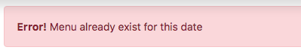

Notification is send to channel of Slack

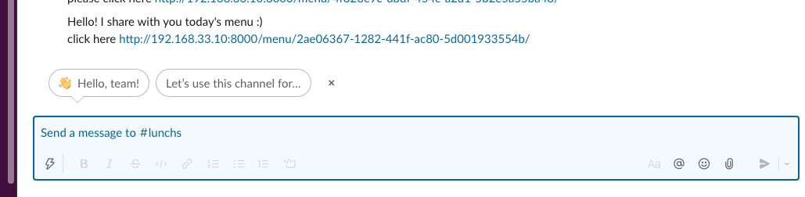

New Order
The employees open link of notification Slack for choice your Lunch and selected your Lunch

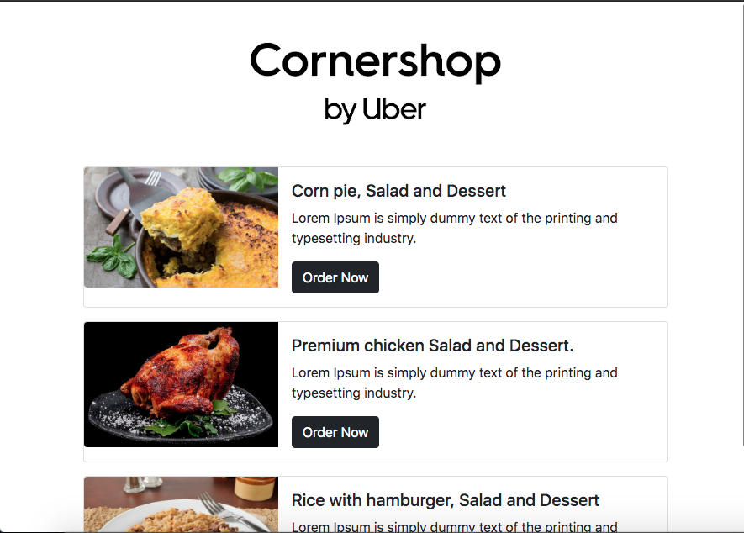

The Employee confirms your order

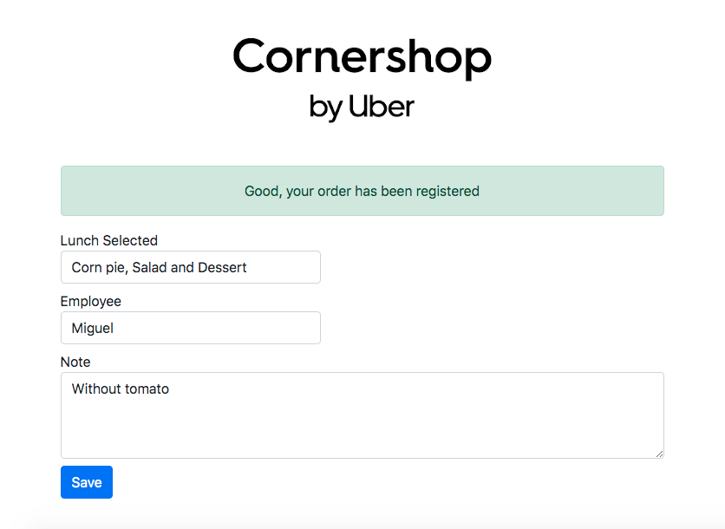

The user admin see the orders

